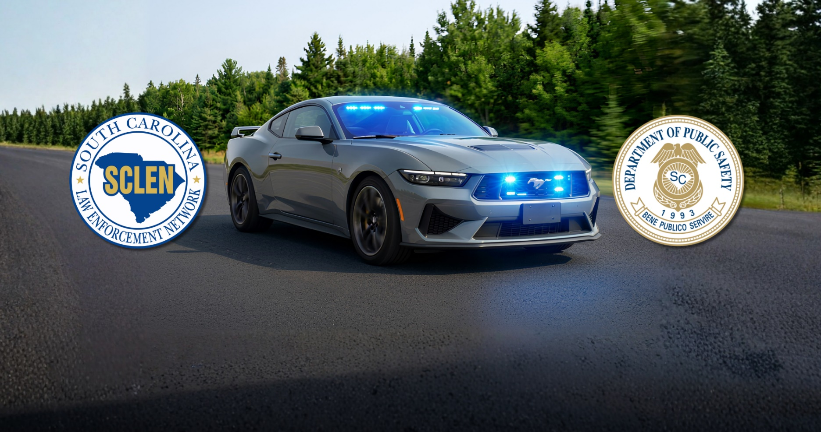

2027 Law Enforcement Challenge
Compete For a Fully Equipped Patrol Vehicle
And Handheld Speed Measuring Devices

CHALLENGE PERIOD: December 1, 2026 – September 6, 2027

Agency Participation Requirements

a) Have a signed Participation Statement on file with OHSJP.
b) Conduct traffic enforcement and educational initiatives as indicated below:
- Conduct monthly proactive traffic enforcement (e.g., checkpoints, saturation/directed patrols) during the challenge period (December 1, 2026 – September 6, 2027).

- Conduct stepped-up DUI enforcement during the 2026 - 2027 Christmas/New Years’ Day Sober or Slammer! Campaign, scheduled for December 16, 2026 – January 1, 2027, in addition to any monthly impaired driving detection and enforcement efforts.

- Conduct stepped-up enforcement of the State’s safety belt and child passenger safety laws during the 2027 Memorial Day Buckle Up, South Carolina Campaign, scheduled for May 18 – 31, 2027.

- Conduct stepped-up enforcement of the State’s speed laws during the 2027 Operation Southern Slow Down Campaign, scheduled for July 12 – 17, 2027.

- Conduct stepped-up DUI enforcement during the 2027 Labor Day Sober or Slammer! Campaign, scheduled for August 11 – September 6, 2027, in addition to any monthly impaired driving detection and enforcement efforts.

- Address Vulnerable Roadway User-related crashes (Motorcyclists, Pedalcyclists, Pedestrians, and Others) in your area. Use educational and enforcement efforts to reduce crashes related to those identified.

c) Submit all 13 required campaign enforcement reports:
Note: To achieve BLUE Level status, 11 out of 13 reports must be completed and submitted within 10 days after the reporting period closes. This allows two (2) reports to be late, and an agency can remain a BLUE level agency. However, those late reports must be submitted within 30 days after the closing of the reporting period.

d) Attend LEN Meetings:
- Attend a minimum of 50% of the scheduled LEN meetings in your SCLEN Circuit (monthly or bi-monthly depending on the meeting schedule of your LEN) held during the challenge period (December 1, 2026–September 6, 2027). Only meetings that are held in person count toward the 50% threshold. The scheduled meetings for the challenge will be a minimum of four (4) and a maximum of nine (9). A sign-in sheet is maintained for each LEN meeting and will be used for verification of attendance.

Note: Agencies experiencing emergency situations, which would preclude attendance at a given meeting, must notify the LEN Circuit Coordinator or Assistant LEN Circuit Coordinator that meeting attendance is not possible, in order to be considered for meeting attendance credit. LEN Circuit Coordinators or Assistant LEN Circuit Coordinators must document on meeting rosters if such notification has been received and approved for credit.

e) Report Public Contacts (Warnings):

- Agencies must comply with the provisions of SC state statute §56-5-6560, which requires reporting of data on non-arrest and non-citation traffic stops to the SC Department of Public Safety (SCDPS). SCDPS rules and regulations require monthly reporting of this data.

- All required Public Contact reports must be submitted before October 1, 2027.

Enforcement Reporting Schedule*

Report Period Required | “From and To” Dates | Due Dates
December 2026 | 12/1/2026 – 12/31/2026 | 01/10/2027
2026-27 Christmas/New Year’s SOS Campaign | 12/16/2026 – 1/1/2027 | 01/11/2027
January 2027 | 1/1/2027 – 1/31/2027 | 02/10/2027
February 2027 | 2/1/2027 – 2/28/2027 | 03/10/2027
March 2027 | 3/1/2027 – 3/31/2027 | 04/10/2027
April 2027 | 4/1/2027 – 4/30/2027 | 05/10/2027
May 2027 | 5/1/2027 – 5/31/2027 | 06/10/2027
2027 Memorial Day BUSC Campaign | 5/18/2027 – 5/31/2027 | 06/10/2027
June 2027 | 6/1/2027 – 6/30/2027 | 07/10/2027
July 2027 | 7/1/2027 – 7/31/2027 | 08/10/2027
2027 Operation Southern Slow Down Campaign | 7/12/2027– 7/17/2027 | 07/27/2027
August 2027 | 8/1/2027 – 8/31/2027 | 09/10/2027
2027 Labor Day SOS Campaign | 8/11/2027 – 9/6/2027 | 9/16/2027

All reports must be submitted before October 1, 2027, to be eligible for any awards.

* 2026/2027 Campaign & Monthly Enforcement Report Form is online at www.scdps.gov/sclen

Public Contact Reporting Schedule

Report Period Required: | “From and To” Dates:
December 2026 | 12/1/2026 – 12/31/2026
January 2027 | 1/1/2027 – 1/31/2027
February 2027 | 2/1/2027 – 2/28/2027
March 2027 | 3/1/2027 – 3/31/2027
April 2027 | 4/1/2027 – 4/30/2027
May 2027 | 5/1/2027 – 5/31/2027
June 2027 | 6/1/2027 – 6/30/2027
July 2027 | 7/1/2027– 7/31/2027
August 2027 | 8/1/2027– 8/31/2027

All reports must be submitted before October 1, 2027

Awards Criteria

Only BLUE level agencies with evidence of active participation through documented enforcement

activities will be eligible for any equipment and prizes.

BLUE LEVEL:

- At least 50% LEN meeting attendance.

- All SCLEN reports submitted as detailed in section (c) above.

- All Public Contact Reports submitted by the deadline.

- Signed Participation Form on file.

NOTE: Completion of the Federal Surplus Property Eligibility Application is required to receive any

equipment items. (You can find the Federal Surplus Property Eligibility Application online at www.scdps.gov/sclen).

Awards and incentive items will be awarded at the 2027 Law Enforcement Challenge Ceremony

2027 Law Enforcement Challenge Participation Statement*

By signing this form, your agency is agreeing to participate in the 2027 Law Enforcement Challenge.

__________________________________________ _____________________________
(Signature of Chief, Sheriff, or Designee) (Date)

Agency: ________________________________________________________________

Agency Address: _________________________________________________________

Contact Person for Law Enforcement Challenge: ________________________________

Phone #: _________________________________

E-mail Address: ____________________________

Contact Person for Public Contact Reporting: __________________________________

Phone #: _________________________________

E-mail Address: ____________________________

Signed Participation Statement Must Be Submitted to the Office of Highway Safety and Justice Programs.

* The participating agency must confirm via phone call or e-mail communication that the Participation Statement has been received by the Office of Highway Safety and Justice Programs.

E-mail or Mail a Signed Participation Statement to:

SC Dept. of Public Safety

Office of Highway Safety and Justice Programs

PO Box 1993

Blythewood, SC 29016

Gilmore S. Owens III Harold Moore

PHONE # (839) 228-5650 or PHONE # (839) 201-2020

E-mail Address: gilmoreowens@scdps.gov E-mail Address: haroldmoore@scdps.gov

